# F16 wall mounted antenna

Technical parameters of wall mounted antenna:

RF frequency range: 450-950MHz

Power supply mode: BNC,9-12VDC

Current: 40mA

Standing wave ratio: ≤ two

Input impedance: 50 ohms

Amplifier bottom noise:< 3.6dB

Gain: 18db (typical)

Polarization mode: Vertical

Front to back ratio: ≥ 25dB

Type of connector: BNC active directional antenna Technical parameters:

The directional feature adopts a logarithmic periodic dipole array, which can provide the best reception effect when facing the desired coverage area. It can be fixed on the wall or fixed on the wall using an integrated rotatable bracket. Low noise signal amplifiers can compensate for the insertion loss of coaxial cables and are compatible with wireless receivers and antenna distribution systems.

■ The integrated bracket with threads can be easily fixed to the microphone stand

■ Directionality: 180 degree pointing

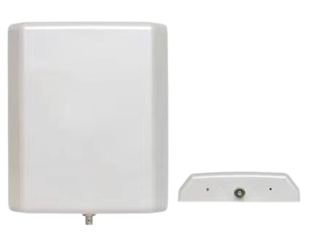High quality, high reliability, and durability directional antenna for the product